(Approx. 479 words)

Are you being followed?
By Linda Gonse, Editor/Webmaster, Orange County PCUG, California
December issue, nibbles & bits
www.orcopug.org
editor (at) orcopug.org

You may not even suspect you are being followed. But, as many as 60 ad networks may be tracking you on the web right now! What’s more, they may be selling personally identifiable details about you.

If this disturbs you, you can put a stop to it. You can quickly opt out from advertising networks —each has multiple clients! — with just a few mouse clicks.

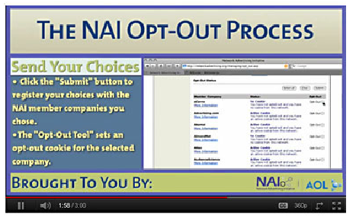
The National Advertising Initiative (NAI) is a cooperative of dozens of online ad networks that track you. An NAI statement says it developed an Opt-out Tool “in conjunction with our members for the express purpose of allowing consumers to ‘opt out’ of the behavioral advertising delivered by our member companies.” To this end, NAI offers a YouTube video on their home page showing you how the Opt-out Tool works. (You can also see the enlarged video before you go to their site at http://bit.ly/ruQt9S)

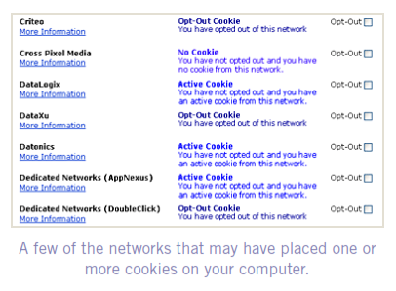
Basically, the Opt-out Tool, which will not be installed on your computer, examines cookies (small text files) on your computer and identifies those member companies that have placed an advertising cookie on it.

When a member company’s cookie is identified by the Opt-out Tool, you simply check the box next to the company name. If you are strongly motivated (or highly frustrated), check the “Select All” box! Then, click the “Submit” button, and you’re done. The cookies will be removed for the selected companies and your opt-out status will be automatically verified.

Go to the NAI website at http://bit.ly/sNMlj0 to get the opt-out process started.

There are two caveats. 1. Opting out of a network does not mean you will no longer see online advertising. But, the network from which you opted out will no longer be tracking you personally and displaying ads that are “tailored to your web preferences and usage patterns.” Isn’t that the idea? 2. Networks voluntarily allow opting out. It isn’t a legal mandate. Also, technical glitches may occur. Cookies from any of these networks may reappear. So, use the Opt-out Tool regularly.

Quantcast Measurement and Advertising does not participate in the National Advertising initiative, but also offers you the ability to opt-out of their ads based on your interests.

Quantcast claims it doesn’t store your IP address or any other personally identifiable information. “But, if you prefer not to receive interest-based content and advertisements enabled by Quantcast and not to have Quantcast measure your pattern of website visits or other online media consumption, you can opt-out by using our opt-out tool” at http://bit.ly/vNAXOB.
Opting out is the only way you can avoid being tagged, tracked and tempted by advertisers who know your purchasing history. By opting out you can end hunting season by advertisers who are determined to bag your money.

